**IST772 Week 5 Breakout – T-Test and Confidence Interval Analysis**

The mtcars dataset is a built-in dataset in R that contains measurements on 11 different attributes for 32 different cars. The data was extracted from the 1974 Motor Trend US magazine and comprises fuel consumption and 10 aspects of automobile design and performance for 32 automobiles (1973-74 models). You will examine the data set to compare the gas mileage of cars with automatic and manual transmissions.

1. Using R, display a boxplot that depicts the distributions of automatic and manual transmissions. **Paste the boxplot below and describe what you see.**

# Plot a boxplot of mpg by transmission type

boxplot(mpg ~ am, data = mtcars, xlab = "Transmission Type", ylab = "Miles per Gallon",

names = c("Automatic", "Manual"), col = c("lightblue", "lightgreen"))  
  
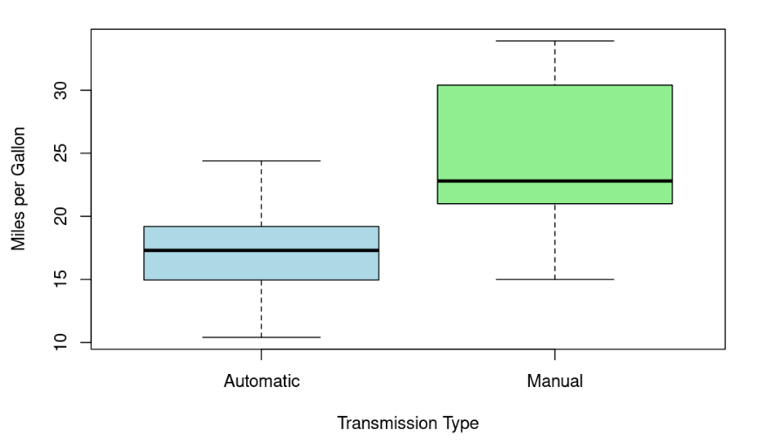

1. Which transmission group is likely to have greater variability in the population? **How did you determine this.**

# Based on the boxplot, we can see that the manual transmission group (represented by the green box) has a greater range of values and more

# variability than the automatic transmission group (represented by the blue box). The manual group has a larger box, which indicates a wider # interquartile range.

# Therefore, we can conclude that the manual transmission group is likely to have greater variability in the population.

1. Write R code calculating the value of the “point estimate” of the mean difference in mpg between the two types of transmissions. **What is this point estimate?**

point_difference <- mean(mtcars$mpg[mtcars$am==1]) - mean(mtcars$mpg[mtcars$am==0])

point_difference

7.24

1. If you have not already done so, install JAGS and then install the BEST package before proceeding. Then use the following code to compare the gas mileage of cars with automatic and manual transmissions by running the BEST procedure. **Write a comment indicating the lower limit and upper limit of the highest density interval (HDI).**

library(BEST)

bestOut <- BESTmcmc(mtcars$mpg[mtcars$am==0], mtcars$mpg[mtcars$am==1])

bestOut

plot(bestOut)

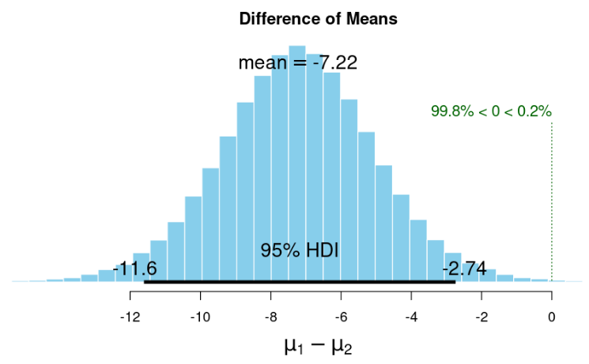

1. **Answer the following.**
2. **Describe what an HDI is.**

An HDI is an interval that represents the range of values that are most plausible for the parameter given the data and the prior information.

1. **Does the HDI overlap with zero?**

No, HDI does not overlap with zero from the plot we see that 0 is in the curve, but not in the HDI.

1. **What percentage of the estimates under the HDI curve is above zero?**

0.2% of the mean difference estimates fall above 0.

1. **What implications does this have for the credibility of a non-zero difference in mpg between automatic and manual transmissions?**

Strong evidence that there are differences in means. HDI interval is from -11.6 to -2.74 and only 0.2% of the estimates from HDI curve fall above zero. We reject the null hypothesis.

1. **Based on the results of the Bayesian t-test, do you prefer automatic transmissions or manual transmissions? Why?**

Based on the results of the Bayesian t-test, we can conclude that there is a statistically significant difference in mpg between automatic and manual transmissions, and that manual transmissions are likely to be more fuel efficient than automatic transmissions. However, the decision to prefer one type of transmission over the other should be based on other factors beyond just fuel efficiency (e.g., driving experience, cost, availability, etc.).

1. Assume for a moment that a typical owner puts a total of about 66,000 miles on a car before selling or trading it and that average gas costs over that period was $0.75 per gallon. **What would you have said to automotive designers or buyers back then?**
2. **In the Discussion in Bb:**
3. Post your answers to #5.
4. Post your answer to the question in #6.